Project Report

AI Air Health Assistant
(AQI Prediction Using Machine Learning)

By - Varun Kumar
3rd March ,2026

INDEX
- Introduction
- Problem Statement
- Objectives
- Methodology
  - Data Collection
  - Data Extraction Using SQL
  - Data Preprocessing
  - Feature Engineering
- Dataset Description
- Exploratory Data Analysis (EDA)
  - Outlier Detection
  - City-wise AQI Trend Analysis
  - AQI Trend Over Time
- Model Development & Selection
  - Problem Type
  - Model Training Process
  - Model Selection
  - Evaluation Metrics
  - Model Deployment
- System Architecture & Implementation
  - System Architecture Overview
  - Data Flow Pipeline
  - Streamlit Application Implementation
  - User Interface Design
- Final Results Summary
- Limitations
- Future Scope
- Conclusion
- References

Introduction
Air pollution has become a serious environmental and public health concern in recent years. Rapid urbanization, industrial growth, increasing vehicle emissions, and construction activities have significantly contributed to the deterioration of air quality. Exposure to polluted air can cause respiratory problems, cardiovascular diseases, reduced lung function, and other long-term health complications. Sensitive groups such as children, elderly individuals, and people with asthma are especially vulnerable.
To monitor and communicate pollution levels, the Air Quality Index (AQI) is used. AQI is a standardized numerical indicator that represents the concentration of major pollutants including PM2.5, PM10, Nitrogen Dioxide (NO₂), Sulfur Dioxide (SO₂), Carbon Monoxide (CO), and Ozone (O₃). Based on the AQI value, air quality is categorized into levels such as Good, Moderate, Unhealthy, and Hazardous, each indicating the degree of potential health risk.
Although AQI data is publicly available, many people do not fully understand what the AQI value means or how it affects their personal health. There is a gap between technical pollution data and user-friendly health awareness.
The AI Air Health Assistant project aims to bridge this gap by using Machine Learning techniques to predict AQI based on pollutant and weather parameters. The system not only predicts AQI values but also classifies them into health categories and provides personalized health recommendations through an interactive Streamlit dashboard.
This project demonstrates how Artificial Intelligence and data analytics can be applied to environmental monitoring, helping users make informed decisions to protect their health.

Problem
Statement
Despite the availability of AQI data through various government and environmental websites, a significant number of people do not have a clear idea about:
- What AQI data is trying to communicate
- The impact of different levels of pollution on their health
- The preventive steps that should be taken in case of poor air quality conditions
Currently, various systems simply display AQI data in numerical format, but do not provide any clear idea about the data itself.
Thus, a new intelligent and interactive system is required that can:
- Predict AQI using various environmental and pollution data
- Provide a clear idea about different levels of pollution in terms of health conditions
- Offer recommendations based on the conditions of the users
- Display results in an interactive format using a dynamic dashboard
The AI Air Health Assistant aims to fill in the gap in current systems by using Machine Learning techniques in conjunction with a dynamic dashboard.

Objectives
The main goal of the AI Air Health Assistant project is to create a smart and user-friendly system that uses Machine Learning techniques to predict the Air Quality Index and offer health-related advice based on the levels of air pollution.
The detailed objectives of this project are as follows:
- Gathering and analyzing air quality information, which includes pollutant levels such as PM2.5, PM10, NO2, SO2, CO, and O3, as well as environmental parameters like temperature and humidity.
- Data preprocessing and feature engineering, which includes handling missing values, creating rolling mean features, and preparing the dataset for model training.
- Developing a Machine Learning model that is capable of making accurate predictions about the Air Quality Index using pollutant and environmental parameters.
- Evaluating the performance of the Machine Learning model using suitable evaluation parameters like Mean Absolute Error and Root Mean Squared Error.
- Classifying the predicted Air Quality Index values, making them more understandable for end users.
- Giving health-related advice to end users based on the predicted Air Quality Index and user health conditions like asthma and respiratory sensitivity.
- To create an interactive Streamlit-based dashboard for displaying real-time predictions, providing visualizations, and having a dynamic user interface.
- To create a useful AI-based environmental monitoring system that can increase public knowledge and assist decision-making.

Methodology
The AI Air Health Assistant project follows a systematic Machine Learning pipeline consisting of data preprocessing, feature engineering, model training, evaluation, and deployment. The overall workflow ensures that raw environmental data is transformed into an accurate AQI prediction system.

- Data Collection
The dataset used in this project contains historical air quality records along with meteorological parameters.
It includes:
- Pollutant concentrations: PM2.5, PM10, NO₂, SO₂, CO, O₃
- Weather features: Temperature, Humidity, Wind Speed
- Target variable: AQI
The dataset was stored in air_quality.csv and loaded using Pandas for analysis and processing.

2. Data Extraction Using SQL
Before preprocessing and modeling, the dataset was accessed and managed using SQL queries. A SQL connector was used to establish a connection between the database and the Python environment.
SQL was used to:
- Retrieve relevant pollutant and weather features
- Filter required records
- Structure data for further analysis
- Ensure organized data handling
Using SQL improved data management efficiency and simulated a real-world data engineering workflow where datasets are stored in databases rather than flat files.
The extracted data was then loaded into Pandas DataFrame for further preprocessing and analysis.

3. Data Preprocessing
Raw environmental datasets often contain inconsistencies and missing values. To ensure reliable predictions, the following preprocessing steps were performed:
• Removal or treatment of missing/null values
• Checking for outliers in pollutant concentrations
• Converting data into appropriate numerical formats
• Sorting data by city and date to preserve chronological order
• Creating lag features (AQI lag1, lag2, lag3, and 7-day rolling mean) separately for each city using groupby to prevent data leakage
• Encoding the city variable using one-hot encoding to enable city-wise learning
• Splitting the dataset chronologically into training and testing sets
Since AQI data is time-dependent, the dataset was divided based on temporal order rather than random shuffling. Additionally, TimeSeriesSplit cross-validation was applied to evaluate the model’s ability to generalize to future data.

4. Feature Engineering
Feature engineering was performed to enhance the predictive performance of the model and capture temporal pollution behavior.
• Lag features (AQI lag1, lag2, lag3) were created separately for each city using groupby to preserve city-wise temporal continuity.
• A 7-day rolling mean feature was generated to capture short-term pollution trends.
• Relevant pollutant and meteorological parameters (PM2.5, PM10, NO₂, SO₂, CO, O₃, temperature, humidity) were selected based on their influence on AQI.
• The categorical city variable was encoded using one-hot encoding to allow the model to learn city-specific pollution patterns.
These engineered features enabled the model to understand temporal pollution dynamics and city-specific trends rather than relying only on single-day pollutant values.

5. Model Training
A supervised Machine Learning regression approach was implemented to predict AQI values for multiple cities (Delhi, Lucknow, and Jaipur).
• Input features included pollutant concentrations (PM2.5, PM10, NO₂, SO₂, CO, O₃), meteorological parameters (temperature, humidity), lag features, rolling mean features, and encoded city variables.
• The target variable was the AQI value.
• Data was split chronologically to preserve time dependency instead of using random shuffling.
• Multiple regression models were trained and compared, including:
- Linear Regression
- Ridge Regression
- Lasso Regression
- Decision Tree
- Random Forest
- Gradient Boosting
- Support Vector Regression (SVR)
Hyperparameter tuning was performed using GridSearchCV to optimize model performance.
The final selected model (Random Forest Regressor) was retrained on the training data and saved as:
best_aqi_model.pkl

6. Model Evaluation
Model performance was evaluated using both hold-out test data and Time Series Cross-Validation to ensure robustness in forecasting future AQI values.
The following regression metrics were used:
• Mean Absolute Error (MAE) – Measures the average magnitude of prediction errors
• R² Score – Measures the proportion of variance explained by the model
Additionally, TimeSeriesSplit cross-validation was applied to simulate real-world forecasting scenarios, where future data is predicted using only past observations.
The Random Forest model achieved the highest R² score among all tested models and demonstrated strong predictive capability across different cities.

7. Deployment Using Streamlit
The trained model was integrated into a Streamlit web application to make it accessible and interactive.
The deployed system performs the following steps:
- Accepts user input (city)
- Loads the trained model
- Predicts AQI in real time
- Classifies AQI into health categories
- Displays color-coded results and personalized health advice
This deployment transforms the Machine Learning model into a real-world AI-powered environmental health assistant.

Dataset Description
The dataset used in the AI Air Health Assistant project consists of historical air quality and environmental measurements. It is designed to analyze the relationship between pollutant concentrations, meteorological conditions, and the resulting Air Quality Index (AQI).
The dataset was stored in a CSV file named:
- air_quality.csv
It was loaded and processed using the Pandas library in Python.

5.1 Features (Input Variables)
The dataset contains the following major features:
1. Pollutant Parameters
These directly affect AQI levels:
- PM2.5 – Fine particulate matter (diameter ≤ 2.5 µm)
- PM10 – Coarse particulate matter (diameter ≤ 10 µm)
- NO₂ (Nitrogen Dioxide)
- SO₂ (Sulfur Dioxide)
- CO (Carbon Monoxide)
- O₃ (Ozone)
These pollutants are primary contributors to air pollution and are widely used in AQI calculation standards.

2. Meteorological Parameters
Weather conditions influence pollution dispersion:
- Temperature
- Humidity
For example:
- High humidity can sometimes increase pollutant retention.

5.2 Target Variable
- AQI (Air Quality Index)
This is the dependent variable that the Machine Learning model aims to predict.
The AQI value represents the overall pollution level based on combined pollutant concentrations.

5.3 Dataset Characteristics
- Structured tabular dataset
- Numerical features
- Supervised learning problem (Regression)
- Target variable is continuous
Since AQI is a continuous numeric value, the problem is treated as a regression task rather than classification.

5.4 Data Preparation Summary
Before training the model:
- Missing values were handled
- Rolling mean features were created
- Irrelevant columns were removed
- Data was split into training and testing sets
This ensured high-quality input data for model training.
Exploratory Data Analysis (EDA)
Exploratory Data Analysis was performed to understand the structure, distribution, and relationships within the dataset before building the Machine Learning model.
EDA helps in:
- Identifying patterns and trends
- Detecting outliers
- Understanding feature importance
- Observing correlation between pollutants and AQI

6.1 Distribution of Pollutants
Histograms and distribution plots were generated for major pollutants such as PM2.5 and PM10.
Observation:
- PM2.5 showed a right-skewed distribution, indicating occasional high pollution spikes.
- Most pollutant values were concentrated in moderate ranges, with some extreme values.
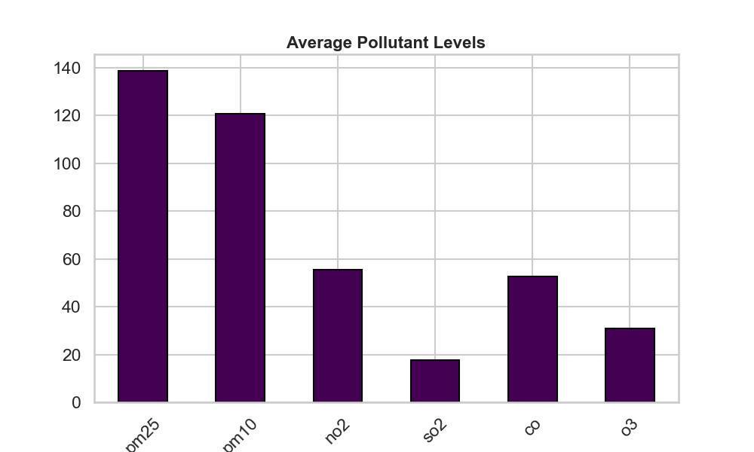

6.2 AQI Distribution
A histogram of AQI values was plotted to understand the frequency of different pollution levels.
Observation:
- Majority of AQI values fall within the moderate to unhealthy range.
- Fewer instances of extremely low or extremely hazardous AQI values were observed.
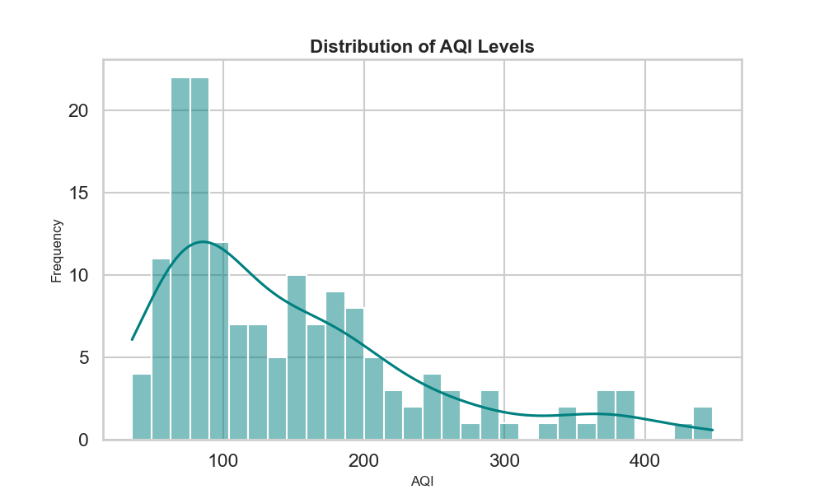

6.3 Outlier Detection
Outliers were detected using boxplots and statistical analysis techniques. Boxplots were created for AQI and major pollutants.
Observations:
- Significant outliers were present in PM2.5 and PM10 concentrations.
- High AQI outliers corresponded to hazardous air quality periods.
- These extreme values represented real-world pollution spikes rather than data errors.
Outlier detection helped ensure that:
- The model remains robust against extreme values.
- Feature engineering decisions were properly informed.
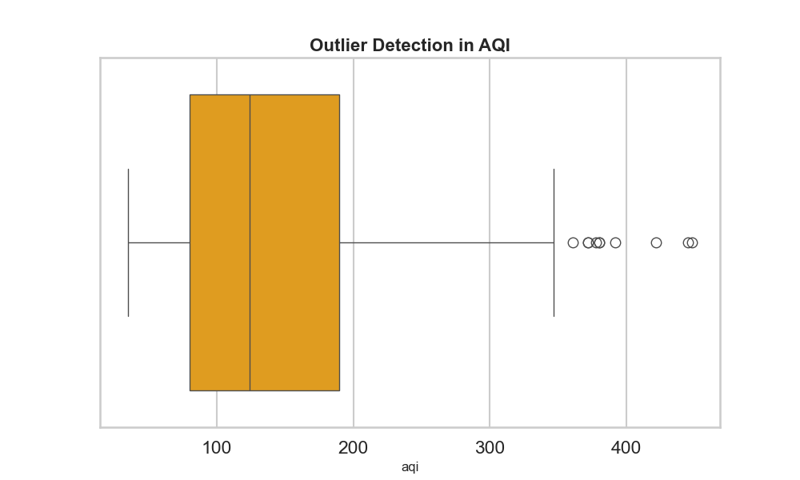

6.4 Correlation Analysis
A correlation heatmap was generated to examine the relationship between input features and AQI.
Observation:
- PM2.5 and PM10 showed strong positive correlation with AQI.
- Wind speed showed negative correlation in several instances.
- Weather features moderately influenced AQI.
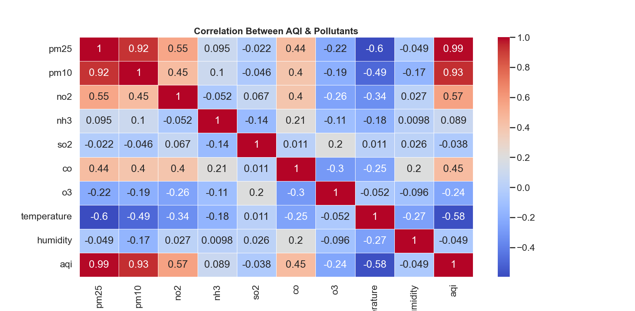

6.5 City-wise AQI Trend Analysis
City-wise AQI trends were analyzed to understand geographical variations in air pollution.
Box Plots were created to compare AQI levels across cities.

Observations:
- Some cities consistently showed higher average AQI values.
- Urban and industrial cities exhibited frequent pollution spikes.
- Certain cities maintained relatively stable AQI patterns.
This analysis highlighted the importance of location-based environmental variations.
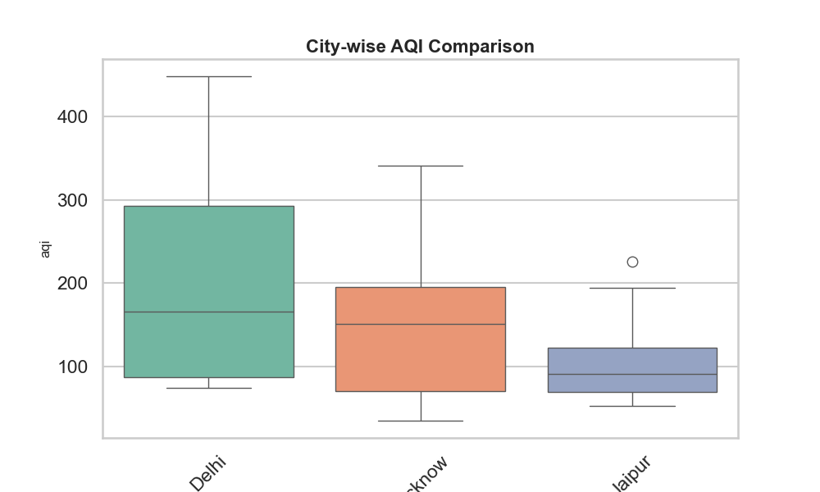
6.6 AQI Trend Over Time
A time-series analysis was conducted to study AQI variation over time.
Line plots were generated using date/time against AQI values.
Observations:
- AQI showed periodic fluctuations.
- Sudden peaks were observed during severe pollution periods.
- Rolling mean trends helped smooth short-term variations and reveal overall patterns.
This justified the inclusion of rolling mean features in the Machine Learning model.
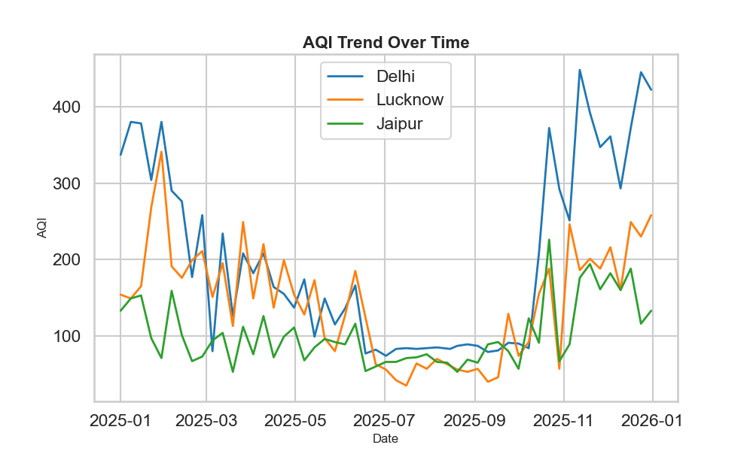

6.7 Key Insights from EDA
The overall EDA revealed the following:
- Particulate matter (PM2.5 and PM10) is the dominant contributor to AQI variation.
- Extreme pollution events significantly impact AQI values.
- Air quality differs across cities due to industrial and environmental factors.
- AQI fluctuates dynamically over time.
- Feature engineering (rolling means) was necessary to capture temporal trends.
These insights directly influenced model selection, feature engineering, and system design decisions.

Model Development and Selection
The core component of the AI Air Health Assistant is the Machine Learning model responsible for predicting AQI values. Since AQI is a continuous numerical value, the problem was treated as a supervised regression task.

7.1 Problem Type
- Learning Type: Supervised Learning
- Task: Regression
- Input: Pollutant and weather features
- Output: Predicted AQI value
Since AQI is a continuous numerical value, the problem was formulated as a regression task. The model learns the relationship between environmental parameters (pollutant concentrations and weather conditions) and AQI using historical data.

7.2 Model Training Process
The dataset was divided into:
- Training Set – Used to train the model
- Testing Set – Used to evaluate model performance
During training:
- Input features were passed into the regression models.
- The models learned patterns between pollutant levels and AQI.
- Internal parameters were optimized to minimize prediction error.
This ensured that the model captured the underlying relationship between air pollutants and AQI levels.

7.3 Model Comparison
To ensure optimal performance, multiple regression algorithms were trained and evaluated. The models were compared using error metrics on the testing dataset.
Selection criteria included:
- Lower prediction error
- Stability on unseen data
- Better generalization performance
A model comparison graph was generated to visually analyze performance differences across models.
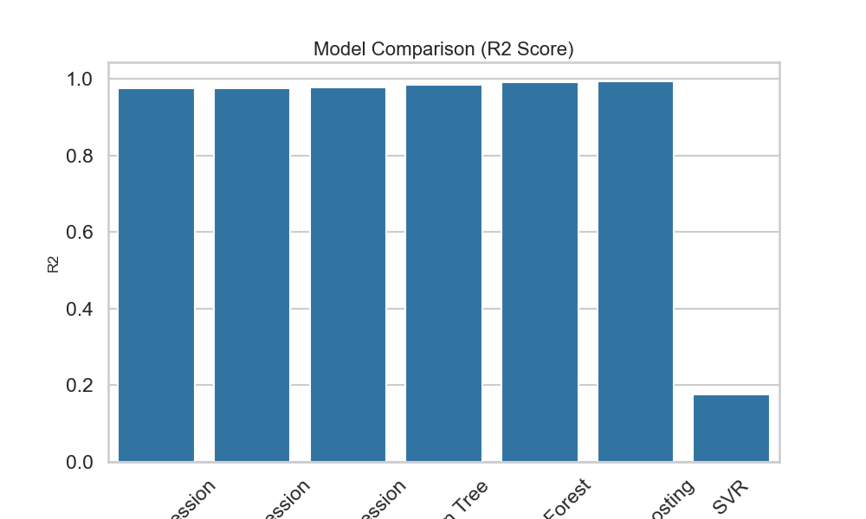
Based on the comparative analysis, the best-performing model was selected.

7.4 Feature Importance Analysis
To improve interpretability, feature importance analysis was conducted.
The feature importance graph illustrates the relative contribution of each input feature toward AQI prediction.

Key Observations:
- PM2.5 emerged as the most influential feature.
- PM10 also showed strong contribution.
- Weather parameters had moderate but meaningful impact.
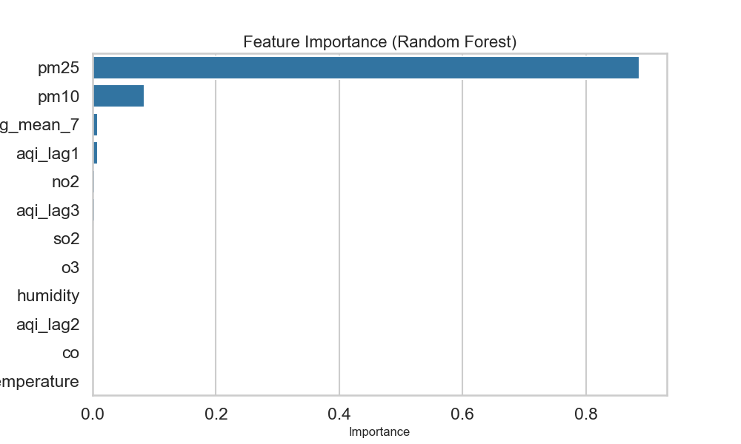
This analysis validated domain knowledge and improved transparency of the model’s decision-making process.

7.5 Evaluation Metrics
The final model was evaluated using standard regression metrics:
- Mean Absolute Error (MAE):
Measures the average absolute difference between predicted and actual AQI values.
- Root Mean Squared Error (RMSE):
Penalizes larger errors more heavily and provides insight into prediction stability.
Lower MAE and RMSE values indicate better predictive performance.

7.6 Final Model Selection and Saving
After comparison and evaluation, the best-performing model was selected and saved as:
best_aqi_model.pkl
The model was serialized using Joblib to enable reuse without retraining.

7.7 Model Deployment
The trained Machine Learning model was successfully deployed through a web-based application developed using Streamlit. The final trained model was saved using the Joblib library as best_aqi_model.pkl.
In addition to the model file, a feature_columns.pkl file was created to store the exact list and order of features used during model training. This ensures that user inputs provided through the application are aligned with the same feature structure expected by the trained model.
During application execution:
• The trained model (best_aqi_model.pkl) is loaded dynamically.
• The feature configuration file (feature_columns.pkl) is also loaded.
• User inputs are arranged according to the stored feature order.
• The processed input is passed to the model for prediction.
• The predicted AQI value is displayed along with severity classification and health recommendations.
The application code is maintained using GitHub and deployed online using **Streamlit Community Cloud, enabling real-time AQI prediction through a web-based dashboard.

System Architecture &
Application Implementation

8.1 System Architecture Overview
The AI Air Health Assistant follows a structured pipeline that transforms raw environmental data into meaningful AQI predictions and health recommendations.
The system consists of the following main components:
- Data Source (air_quality.csv via SQL connector)
- Data Preprocessing Module
- Machine Learning Model (best_aqi_model.pkl)
- Streamlit Web Application Interface
- Visualization and Health Advisory Module
The overall workflow can be summarized as:
k
Data → Preprocessing → Model Prediction → AQI Categorization → Health Advice → Dashboard Visualization

8.2 Data Flow Pipeline
The system operates in the following sequence:
- The dataset is connected using a SQL connector.
- Data cleaning and preprocessing are applied.
- Feature engineering is performed (including rolling mean features and previous AQI values).
- The trained model is loaded using Joblib.
- User inputs are passed into the model.
- The predicted AQI value is generated.
- The AQI is classified into severity categories.
- Health recommendations are dynamically displayed.
This structured pipeline ensures accurate and real-time predictions.

8.3 Streamlit Application Implementation
The web-based user interface of the AI Air Health Assistant was developed using Streamlit, which allows rapid development of interactive data science applications. The application was configured using a wide layout to provide a better visualization space for charts and analytics.
The trained machine learning model was saved using the Joblib library and integrated into the Streamlit application. When the application starts, the model is automatically loaded, allowing real-time AQI predictions based on user-provided pollutant values.
The application is hosted online through **Streamlit Community Cloud, and the source code is maintained on GitHub for version control and deployment.
Key Features of the Application:
- City selection dropdown for selecting different locations
- Real-time AQI prediction based on pollutant inputs
- Color-coded AQI severity indicator for quick interpretation
- AI-generated health advice based on predicted AQI levels
- 365-day AQI trend visualization using interactive charts (Plotly)
- Pollutant concentration breakdown using bar charts
- Health risk analysis metrics for different pollution levels
- Downloadable AQI prediction report for user.
- Alert notifications for hazardous AQI conditions
The application provides an interactive and user-friendly environment that enables users to analyze air quality conditions and understand potential health risks effectively.
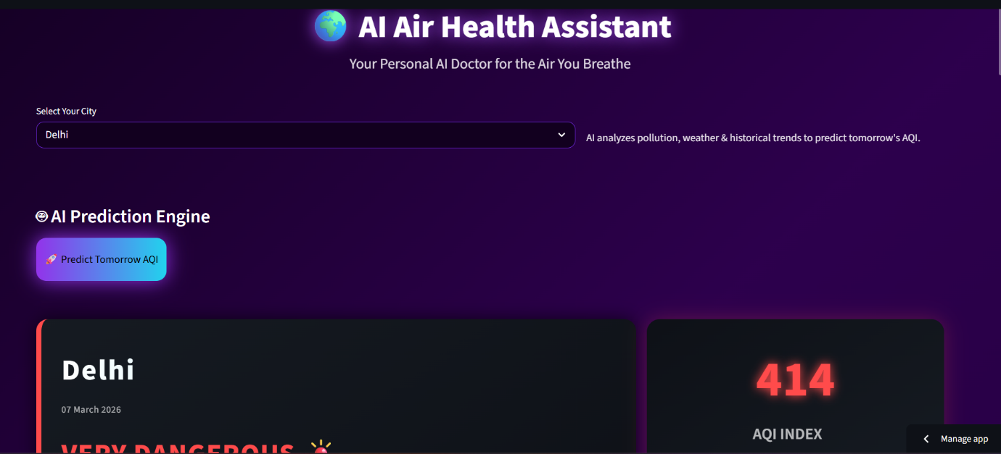
AI Air Health Assistant Streamlit Dashboard

8.4 User Interface Design
The user interface of the AI Air Health Assistant dashboard was designed to provide a clear, interactive, and visually engaging experience for users. The interface was developed using Streamlit, allowing dynamic interaction between the user inputs and the machine learning model predictions.
The dashboard layout was structured to ensure easy navigation and efficient presentation of air quality information. Users can input pollutant concentrations, view predicted AQI values, and analyze health risk indicators through interactive visual components.
Key UI design features include:
• Glassmorphism-inspired panel layout for modern visual presentation
• Gradient background themes for improved aesthetics
• Neon-styled interactive buttons for key actions
• Responsive dashboard layout for better screen utilization
• Dynamic color-coded AQI severity indicators
• Interactive data visualizations for AQI trends and pollutant breakdown
These design elements enhance user engagement while maintaining clarity and readability of critical environmental health information. The interface ensures that users can quickly interpret AQI predictions and understand the associated health risks.
Final Results Summary

9.1 Model Performance Summary
After training and comparing multiple regression models:
- The best-performing model was selected based on lowest MAE and RMSE.
- The model demonstrated stable performance on unseen test data.
- Feature importance analysis confirmed that PM2.5 and PM10 were the dominant contributors to AQI prediction.
- This model was later integrated into the deployed prediction system.
The final model was saved as:
best_aqi_model.pkl

9.2 Analytical Insights Achieved
Through Exploratory Data Analysis (EDA), the following insights were obtained:
- AQI varies significantly across cities.
- AQI shows dynamic fluctuations over time.
- Outliers correspond to real-world pollution spikes.
- Particulate matter is the strongest contributor to AQI variation.
- Rolling mean features improved temporal understanding of pollution trends.

9.3 System-Level Achievements
The deployed web application developed using Streamlit successfully provides:
- Real-time AQI prediction
- Severity-based AQI categorization
- Personalized AI-based health advice
- 365-day AQI trend visualization
- City-wise AQI comparison
- Pollutant breakdown charts
- Health risk metrics
- Downloadable AQI report
- Alert notification for hazardous AQI

9.4 End-to-End Workflow Completion
The project successfully implemented a complete AI pipeline:
Data Collection
↓
Data Preprocessing
↓
Feature Engineering
↓
Model Training & Evaluation
↓
Model Saving (best_aqi_model.pkl)
↓
Streamlit Web Application
↓
Real-Time AQI Prediction Dashboard

This confirms that the system is not just a prediction model, but a fully functional AI-powered environmental health assistant.
Limitations
While the AI Air Health Assistant performs effectively in predicting AQI and providing health insights, certain limitations remain:

1. Dependence on Historical Data
The model is trained on historical AQI and environmental records. Its performance depends heavily on the quality, completeness, and consistency of past data. Any inaccuracies or missing patterns in historical data may affect future predictions.

2. Limited Real-Time Adaptability
The system currently operates on structured datasets and does not integrate real-time AQI APIs or live sensor feeds. As a result, predictions may not reflect sudden real-world fluctuations.

3. Restricted Geographic Coverage
The model is trained on selected cities (Delhi, Lucknow, and Jaipur). Although city-wise features are incorporated, the model may not generalize well to cities with significantly different environmental conditions.

4. Sensitivity to Sudden Environmental Events
Time-series models rely on historical trends. Unexpected pollution spikes caused by wildfires, industrial accidents, weather anomalies, or policy changes may not be accurately forecasted.

5. Feature Dependency
The model heavily relies on pollutant concentrations (especially PM2.5). If key pollutant data is unavailable or inaccurate, prediction performance may degrade.

6. Simplified Health Advisory System
Health recommendations are rule-based and generalized according to AQI categories. The system does not account for individual medical history, age, or pre-existing respiratory conditions.
Future Scope
Although the AI Air Health Assistant successfully predicts AQI and provides health guidance, several enhancements can further improve its functionality and real-world impact.

11.1 Real-Time API Integration
Currently, the system works on structured dataset inputs. In the future, it can be integrated with real-time air quality APIs to fetch live pollutant data and provide instant AQI predictions for any city.

11.2 Deep Learning Models
Advanced models such as Artificial Neural Networks (ANN) or LSTM (Long Short-Term Memory) networks can be implemented to improve time-series forecasting accuracy for AQI trends.

11.3 Mobile Application Deployment
The system can be extended into a mobile application to increase accessibility and provide real-time pollution alerts directly to users.

11.4 Geolocation-Based Prediction
Integration with GPS services can allow automatic location detection and provide AQI predictions specific to the user’s current area.

11.5 Alert & Notification System
A smart notification system can be developed to:
- Send warnings when AQI crosses hazardous levels
- Provide health reminders for sensitive individuals
- Suggest precautionary measures in real time

11.6 Advanced Analytics Dashboard
Future improvements can include:
- Predictive AQI forecasting for upcoming days
- Seasonal pollution pattern analysis
- Comparative city ranking system
- Integration with health data for deeper analysis

11.7 Cloud Deployment
The application can be deployed on cloud platforms to support:
- Large-scale usage
- Real-time data processing
- Continuous model updates

11.8 Real World Improvements
- Real-time AQI API integration
- Mobile responsive UI
- Location-based AQI alerts
- Integration with health advisory systems

The AI Air Health Assistant has strong potential to evolve into a comprehensive environmental monitoring and public health support system.

Conclusion
The AI Air Health Assistant project successfully demonstrates the application of Machine Learning in environmental data analysis and public health awareness. The system was designed to predict Air Quality Index (AQI) values using pollutant and environmental parameters, while also providing meaningful health recommendations to users.
The project followed a structured approach beginning with SQL-based data extraction, followed by data cleaning, preprocessing, and detailed Exploratory Data Analysis (EDA). Statistical analysis and visualization techniques helped identify key pollution patterns, city-wise trends, time-based fluctuations, and significant outliers.
Multiple regression models were trained and evaluated using performance metrics such as MAE and RMSE. After comparing model performance and analyzing feature importance, the most accurate and stable model was selected and deployed. The trained model was integrated into a Streamlit-based interactive dashboard, enabling real-time AQI prediction and visualization.
The final application combines:
- Data engineering (SQL integration)
- Data analysis (EDA and trend analysis)
- Machine learning (model comparison and evaluation)
- Deployment (interactive web dashboard)
By converting raw environmental data into actionable insights and personalized health advice, the AI Air Health Assistant bridges the gap between technical modeling and real-world impact.
Overall, the project reflects a complete end-to-end AI pipeline and demonstrates practical problem-solving using data science and machine learning techniques.

References
- Central Pollution Control Board (CPCB). National Air Quality Index (AQI) Framework. Government of India. Available at: https://cpcb.nic.in
- World Health Organization (WHO). Air Quality Guidelines – Global Update. WHO Press.
- MSN Weather. Air Quality Forecast Data – Loni, Uttar Pradesh. Available at: https://www.msn.com
- Fabian Pedregosa, Gaël Varoquaux, Alexandre Gramfort, et al. (2011). Scikit-learn: Machine Learning in Python. Journal of Machine Learning Research, 12, 2825–2830.
- Wes McKinney (2010). Data Structures for Statistical Computing in Python. Proceedings of the 9th Python in Science Conference.
- John D. Hunter (2007). Matplotlib: A 2D Graphics Environment. Computing in Science & Engineering.
- Plotly Technologies Inc. (2015). Collaborative Data Science. Available at: https://plotly.com
- Streamlit (2023). Streamlit Documentation. Available at: https://docs.streamlit.io
- Joblib Development Team. Joblib: Running Python Functions as Pipeline Jobs. Available at: https://joblib.readthedocs.io

